Assignment-16.6:

Write a map reduce program to join the below given two datasets using Reducer side join:

Driver Class:

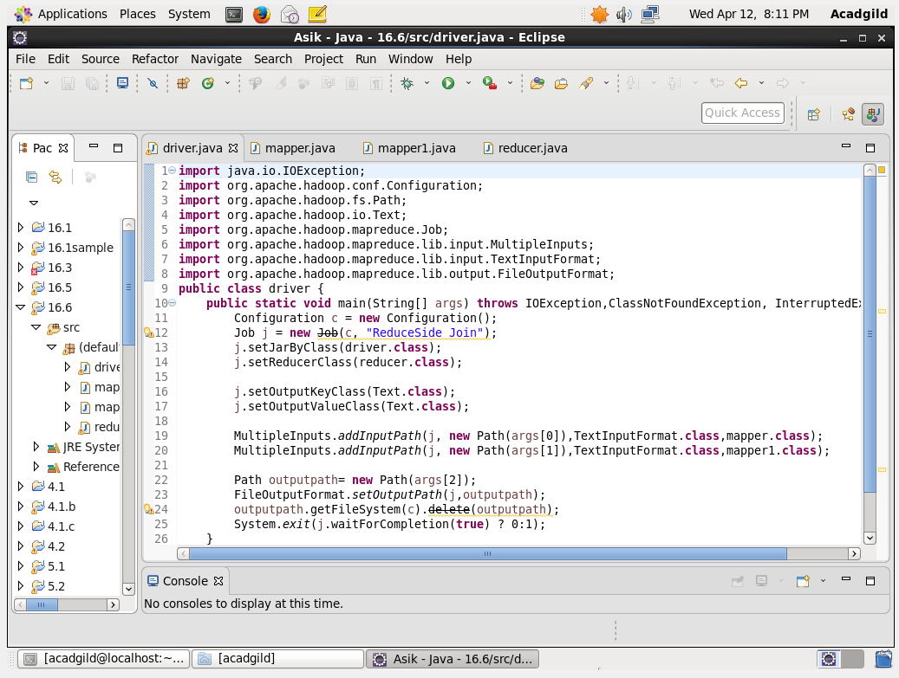

Mapper Class-1:

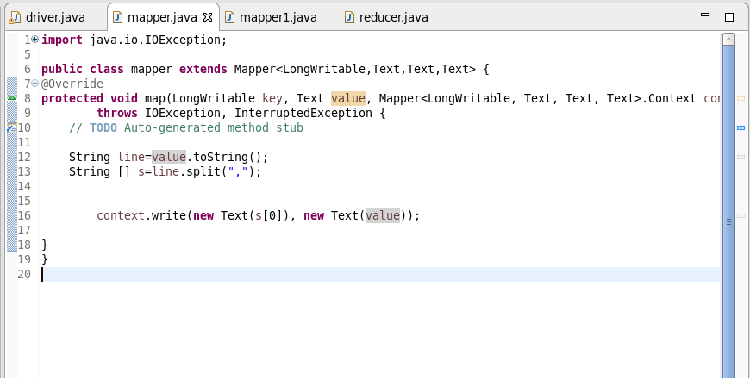

Mapper Class-2:

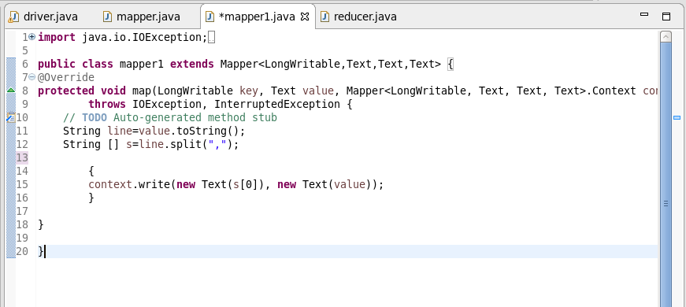

Reducer Class: The Common key is ID

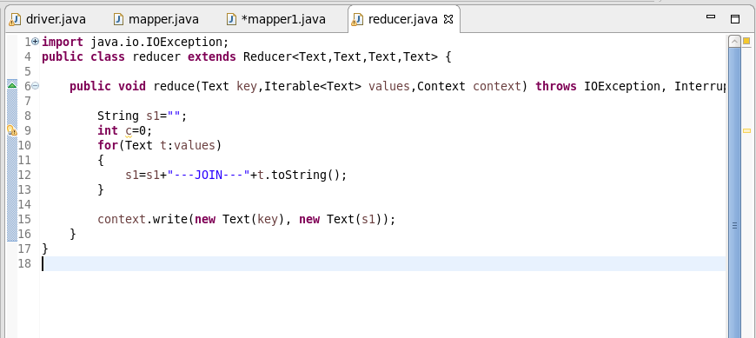

Running the Jar Files:

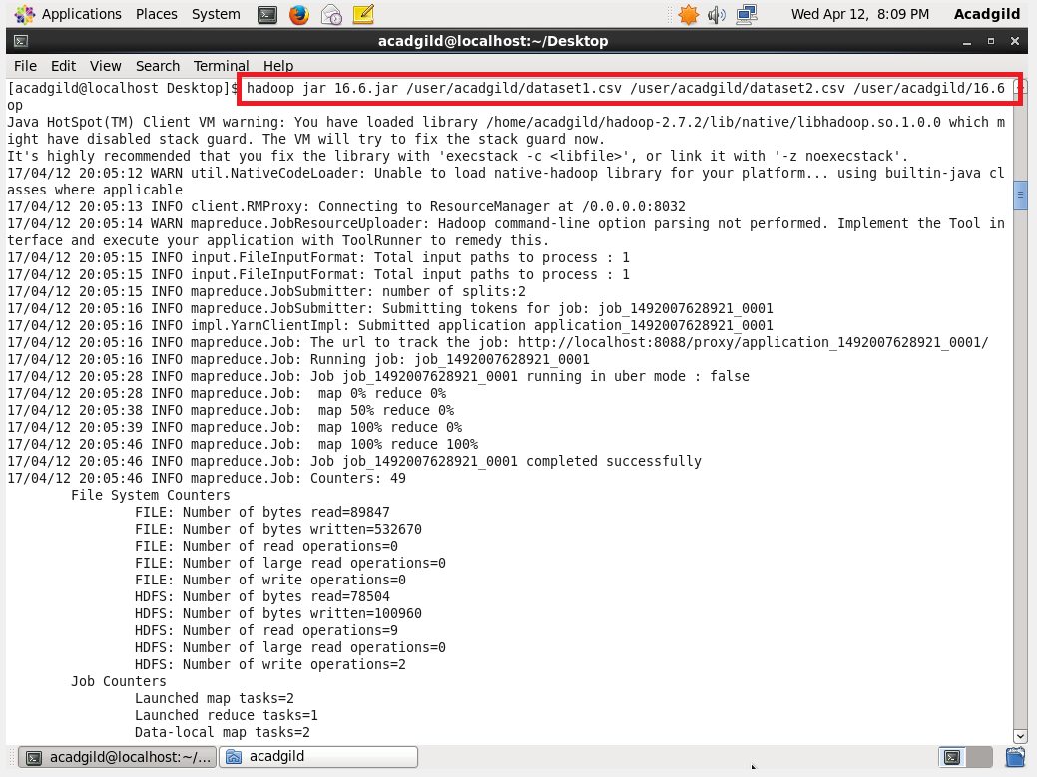

Output:

